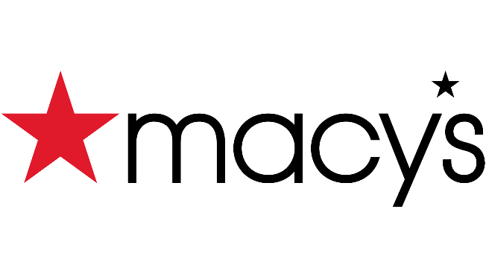
HIRING EVENT
September 22nd
^{12-6p}
Join the Macy’s team today &
earn more than just a paycheck!

Scan this QR code!

macysJOBS.com
-Fully Funded Education Program that covers 100% of tuition, books, and fees.
-Flexible Time Off: Take an extra day off for a holiday that’s most important to you!

