May 26, 2021

Re: Emergency Notification System – New User Sign-up

Dear Operator,

This letter is to make you aware that we will be switching our Emergency Notification Provider to Alert Media. Please use the QR Code copied below to start the Registration of New User.
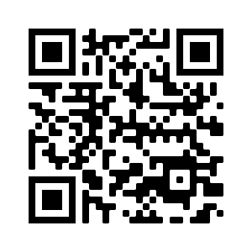
The QR Code will directed to the site: https://pyramid.alertmedia.com/public/v1

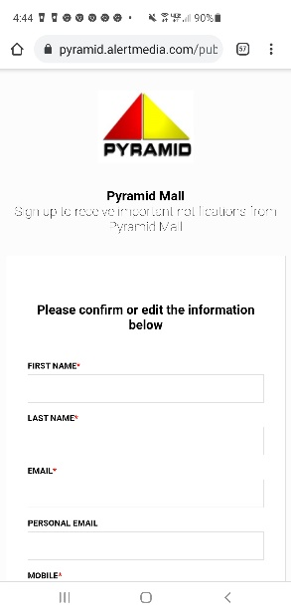

This site will ask you for contact information and Communication Preference – please use the drop-down menu to select your center.

If you have any questions please reach out to the mall office. Thank you for your time and participation in this program.

Sincerely,

Destiny USA Management Team

