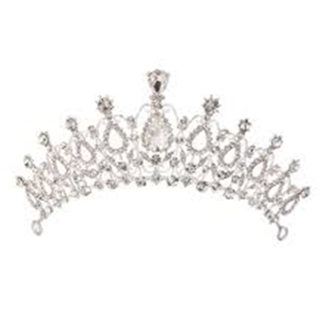
Find your Perfect Prom look at Macy’s Destiny!
Come in and purchase a prom dress anytime during the month of May and mention Macy’s prom event or show your student ID at register to receive
30% off
your sale or full price prom dress
(some limited exclusions do apply)
And don’t forget to visit our Shoe, Jewelry and Beauty Departments to complete your look!
Mention this event with any purchase in Beauty
during May to receive a free treat!


