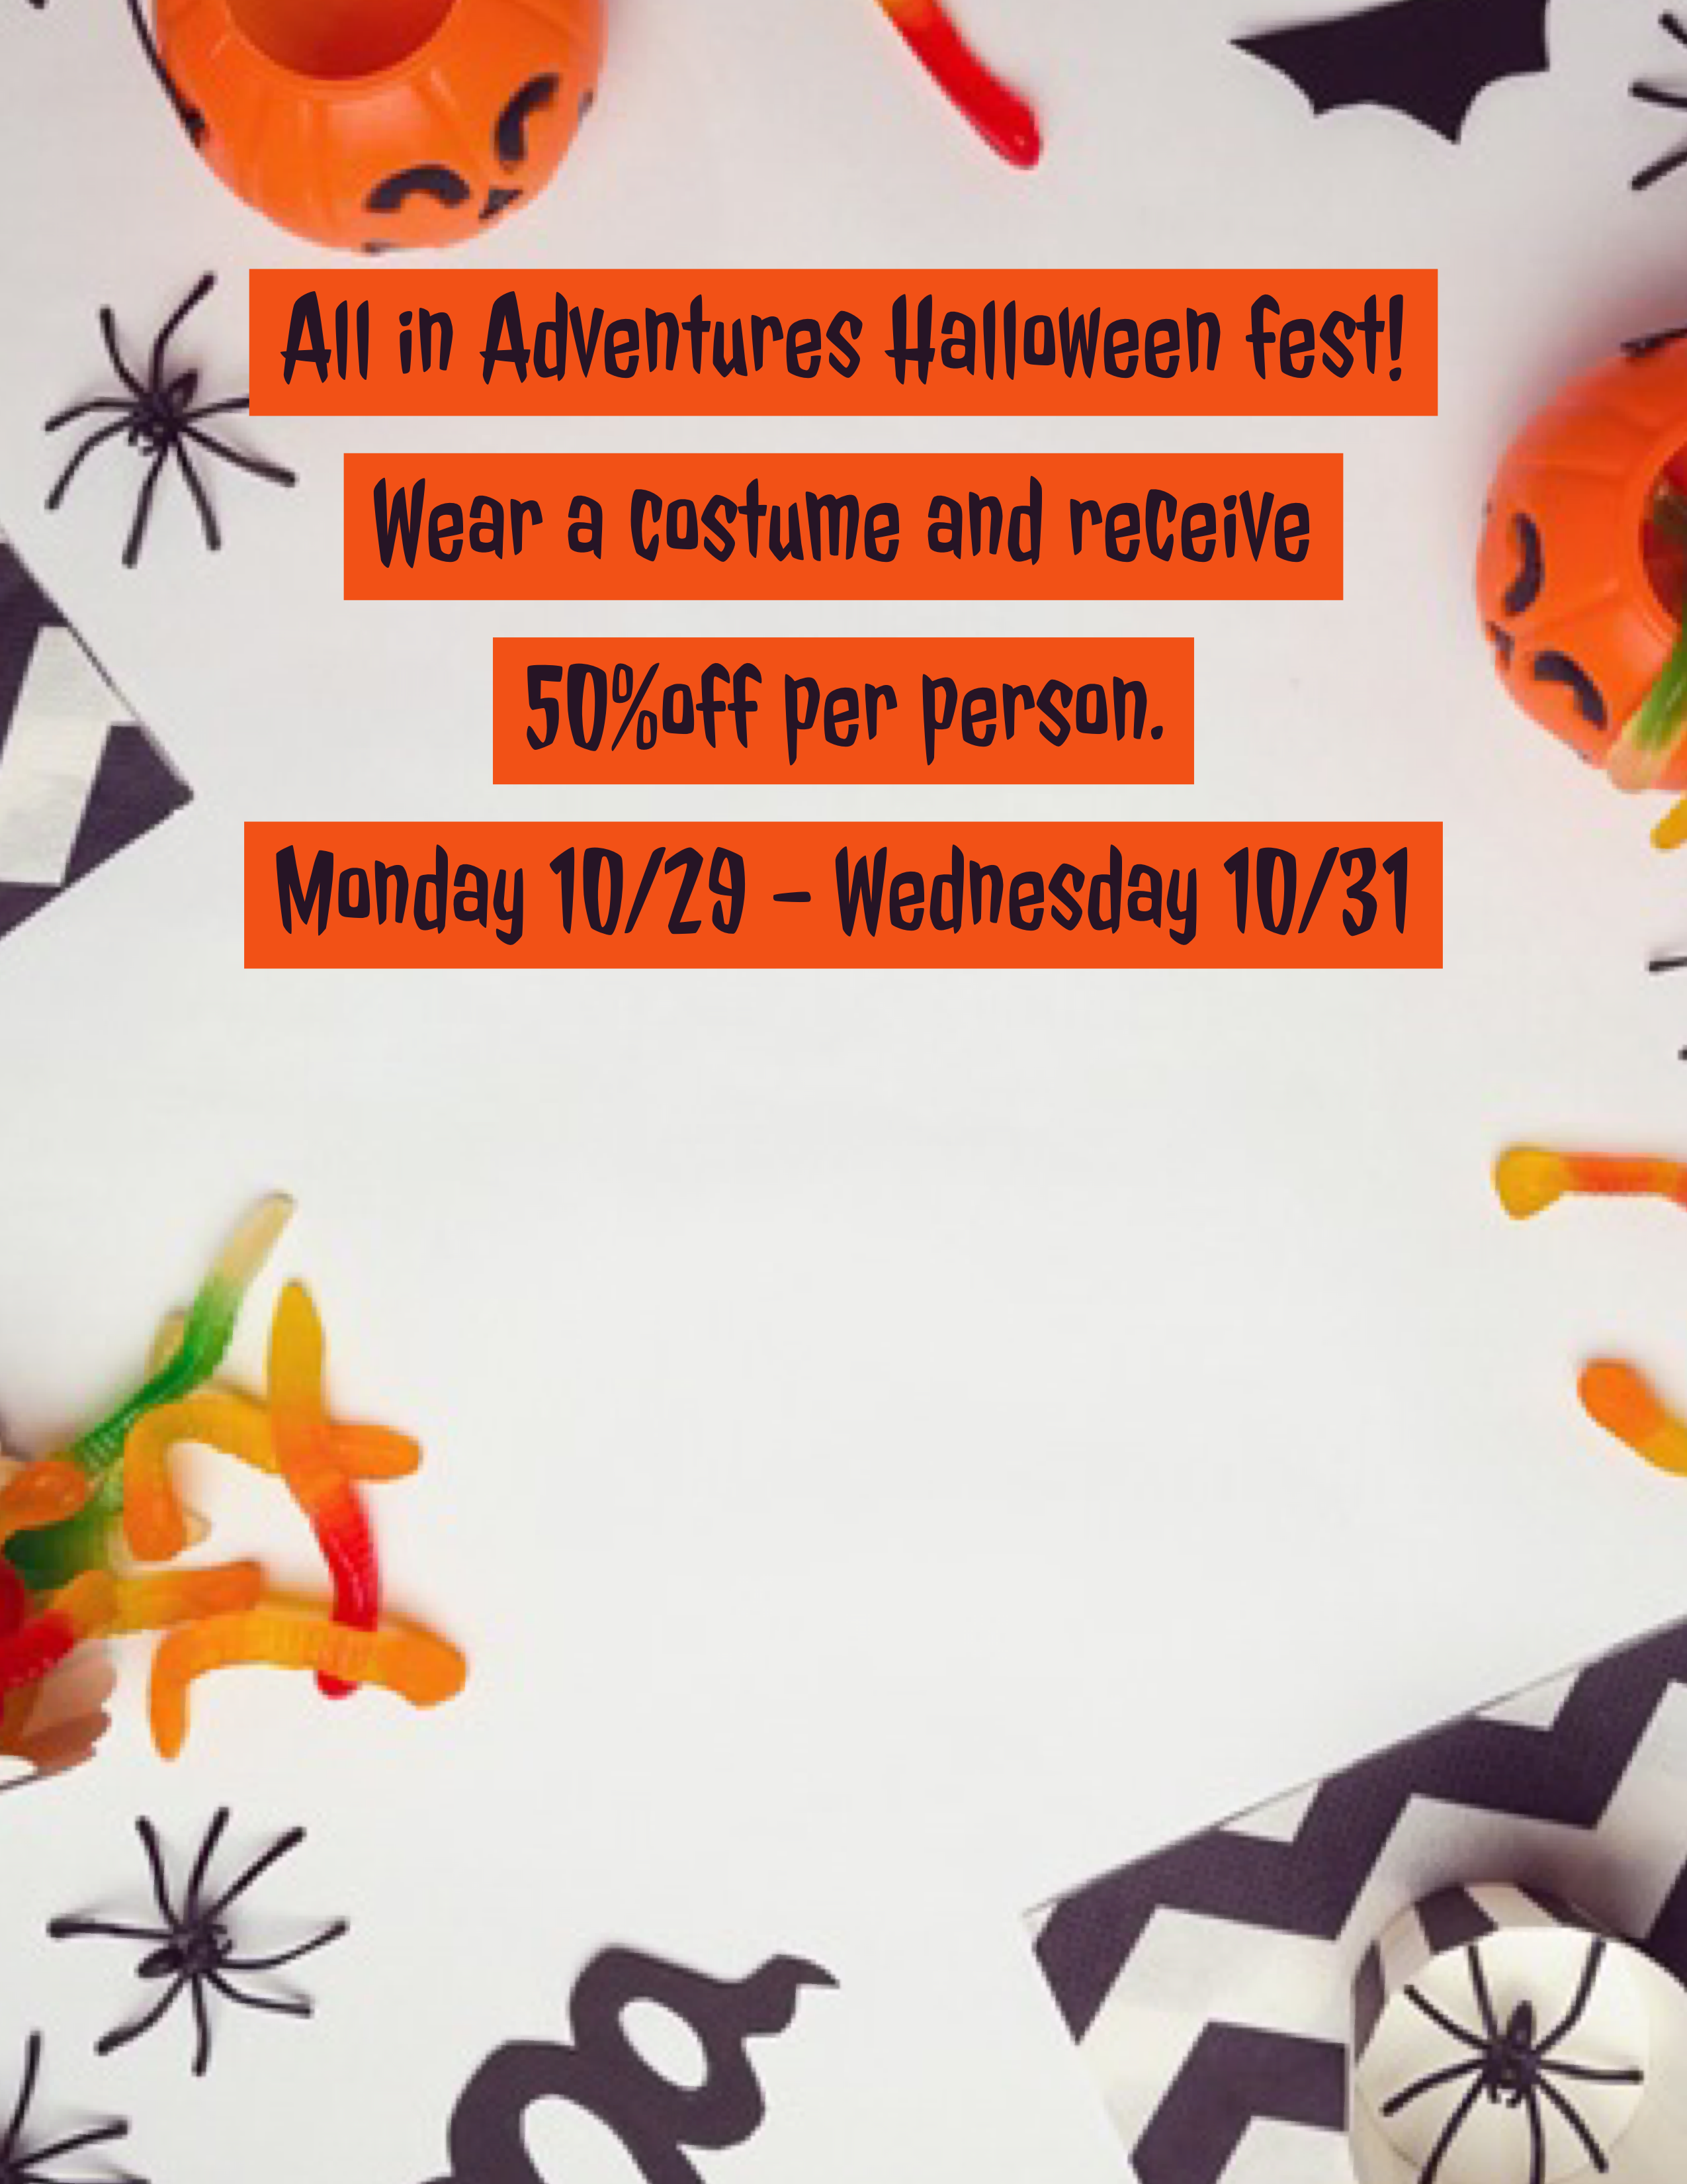
Receive 10% off your birthday party with the purchase of a game and food package! Stop by or call your local store for details!
Receive 10% off your birthday party with the purchase of a game and food package! Stop by or call your local store for details!
Discount not be combined with any other offers
Quantities are limited

9090 Destiny USA Dr
Syracuse NY 13204
Email us at store107@allinadventures.com
Phone:315-423-5140

Stop in for a free picture and candy from us at
Escape The Mystery Room!

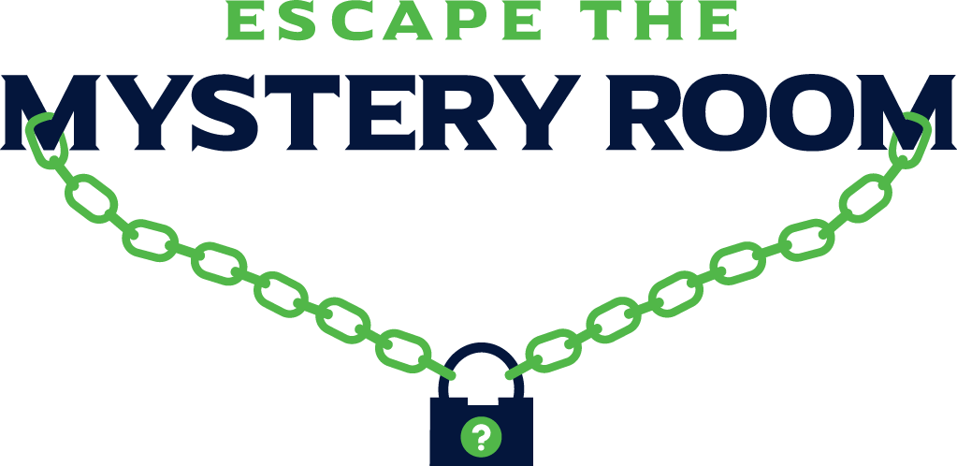
Escape From Alcatraz : Black Op’s: Treasure Island : Houdini’s Magic Cell : Zombie Apocalypse : Sherlock’s Library : Special Agent : Superhero’s Adventure : Hollywood Premier

