Appetizers

Tequila Shrimp 10
Chilled Tequila Poached Shrimp Spicy Tomato Dip

Crispy Pretzel 8
Beer Cheese Honey Mustard

Loaded Salt Potato 8
Bacon Cheese Scallions Sour Cream

Crispy Wings 10
Buffalo BBQ, Lemon Pepper or Plain

Crab Cakes 12
Sriracha Cocktail Remoulade

Stacks Combo 12
Traditional BLT Caprese Blue Bandit

Soups

Hearty Tomato 5
Chunky Vegetables

Rotisserie Chicken 7
Roasted Root Vegetables

Salads

Add Rotisserie Chicken 3 Poached Tequila Shrimp 5
Garnished with Mini Stacks

Wedge 10
Iceberg Cucumbers Tomatoes
Crumbled Blue Cheese Bacon

Caesar 8
Romaine Asiago Croutons Caesar Dressing

Harvest 10
Seasonal Greens Butternut Squash Craisins Red Onion
Sunflower Seeds Goat Cheese Cranberry Vinaigrette

Wood Fire Pizza 10

Fresh Syracuse’s DeLauro’s Dough
Tomato Sauce Mozzarella
Toppings .50 each
Bacon Chicken Pepperoni Sausage Mushrooms Onions Peppers Olives Jalapenos

Sides 4

Fresh Cut Fries
Seasonal Grilled Vegetables
Fresh Fruit Cup
Hearty Broth Risotto
Creamy Polenta

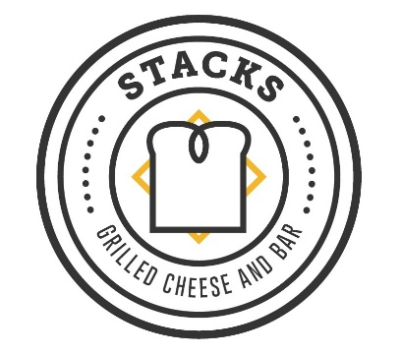

STACKS
Creative Grilled Cheese Sandwiches
Served on Syracuse’s DeLauro’s Bakery Bread

The Traditional 10
Cheddar Provolone Havarti

Blue Bandit Crispy Chicken 12
Buffalo Sauce Blue Cheese Havarti

Green Goddess 12
Avocado Pesto Kale Spinach Monterey Jack Feta

Stacks Crab Cake 16
Remoulade Arugula Gruyere

Caprese 12
Pesto Chicken Tomato Fresh Mozzarella

“BLT” 12
Bacon Arugula Tomato Dijon Sharp Cheddar

Deutsch 14
Hoffman Beer Brat Sauerkraut Spicy Mustard Cheddar

Served with a Choice of
Fresh Cut Fries Tomato Soup
Side Salad or Fresh Fruit

Entrees

Steak Burger 16
10 oz Steak Burger Poppy Seed Onion Roll
Fresh Cut Fries

Rotisserie Half Chicken 18
Hearty Broth Risotto Grilled Vegetables

Syracuse Riggies 18
Rigatonis Chicken Hot Peppers Creamy Tomato Sauce

Grilled Eggplant 16 Vegan
Sundried Tomato Chutney Creamy Polenta

Tequila Poached Shrimp 22
Southwest Risotto Lime Dijonaise

Beef & Blue Pasta 22
Tenderloin Medallions Noodles Creamy Blue

12 oz Gilled Ribeye 22 Gluten Free
Garlic Herb Butter Fresh Cut Fries

Panko Crusted Salmon 22
Dijon Mustard Crust Basil Citrus Butter Sauce
Hearty Broth Risotto

