  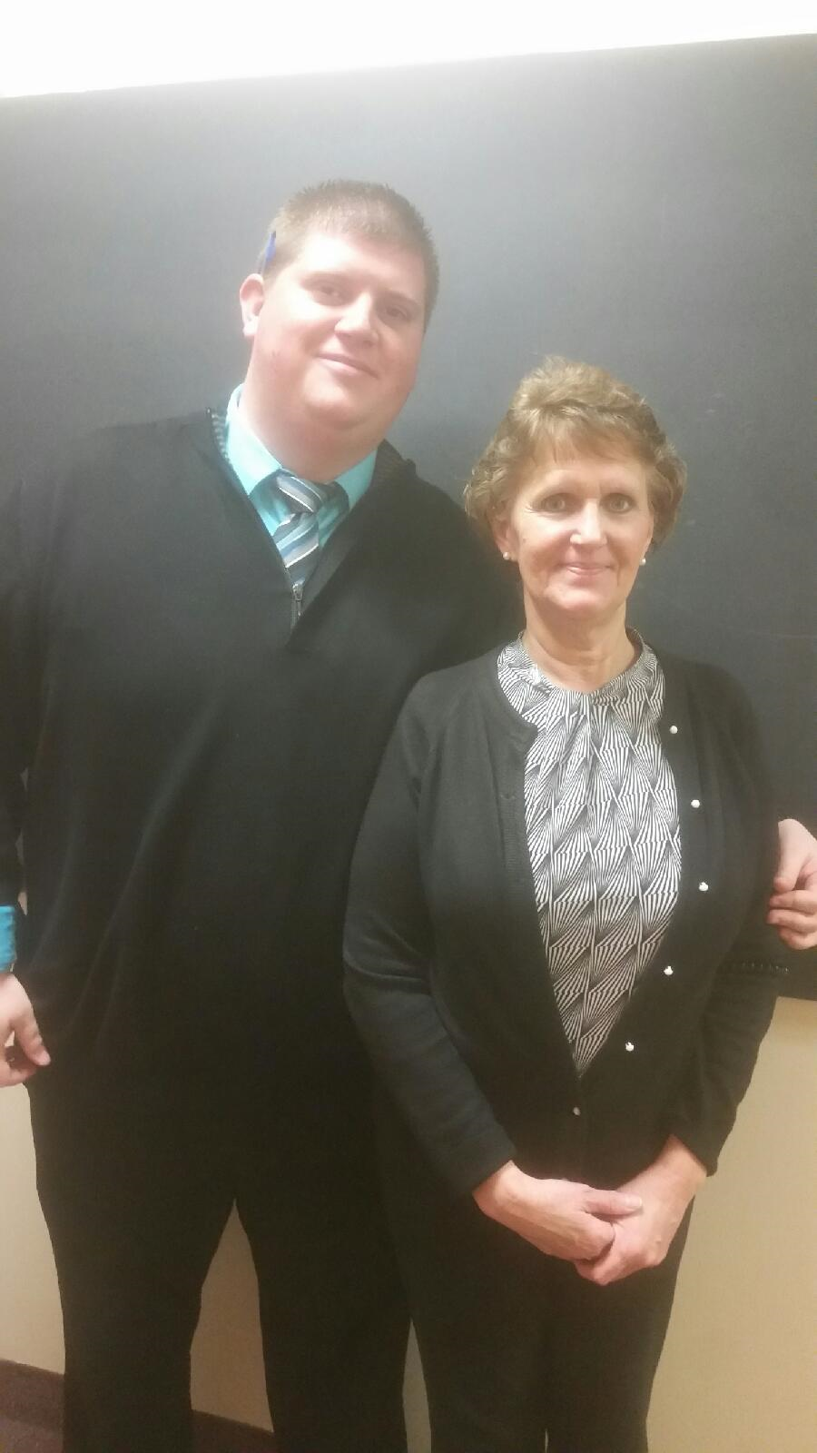
  Your Celebrity Bartenders
  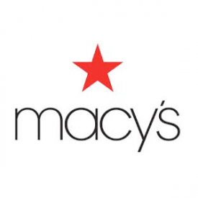Sean Marshfield and Alyce Rodgers will be mixing it up to raise money for Vera House, INC. Can’t attend? Please consider making a contribution to Vera House if you are unable to partake in the event. Payable to: Vera House, INC 6181 Thompson Road, Syracuse, NY 13206
  
  A portion of the sales will go to Vera House, INC!
  Did you know: It is the mission of Vera House, Inc.
  to end all domestic and sexual violence, to assist families in crisis, to support those affected by domestic and sexual violence to live safe, self-sufficient lives, to empower women and children, and to promote a culture of equality and respect in all relationships.
  Happy Hour food and drink specials. Ask about out Destiny Employee Loyalty Program!
  Uno Pizzeria & Grill
  9558 Destiny USA Dr.
  Syracuse, NY 13204
  www.unos.com
  Sunday January 31, 2016
  7-9PM

