  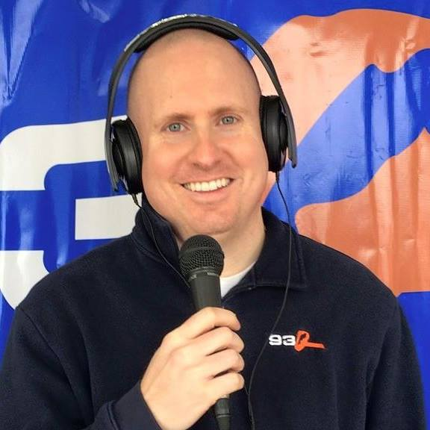
    - 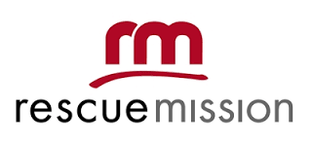Rick Roberts is usually mixing the music but tonight he will be mixing your drinks as your celebrity bartender! Come meet Rick and support the rescue mission! Can’t attend? Please consider making a contribution to the Rescue Mission if you are unable to partake in the event. Payable to: The Rescue Mission Alliance of Syracuse 155 Gifford Street Syracuse, NY 13202
  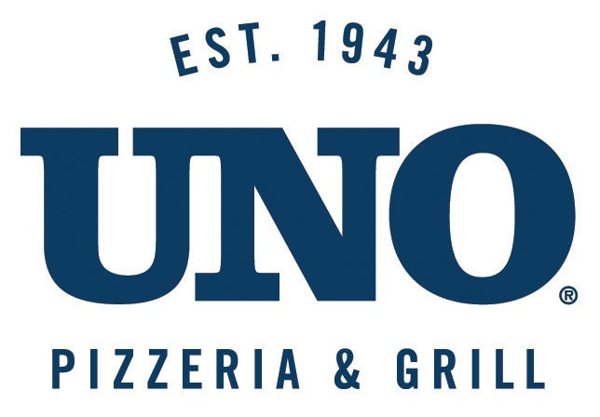
  The rescue mission has been changing lives for more than a century so tonight a portion of all bar sales will be donated to them! Please come support your local RESCUE MISSION.
  Since 1887, the Rescue Mission has helped those in need in Syracuse. Our campus in the Mission District provides emergency shelter, clothing, and three free meals every day of the year!
  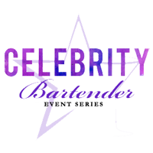
  Uno Pizzeria & Grill
  9558 Destiny USA Dr.
  Syracuse, NY 13204
  www.unos.com
  Thursday Feb.18, 2016
  6-8PM

