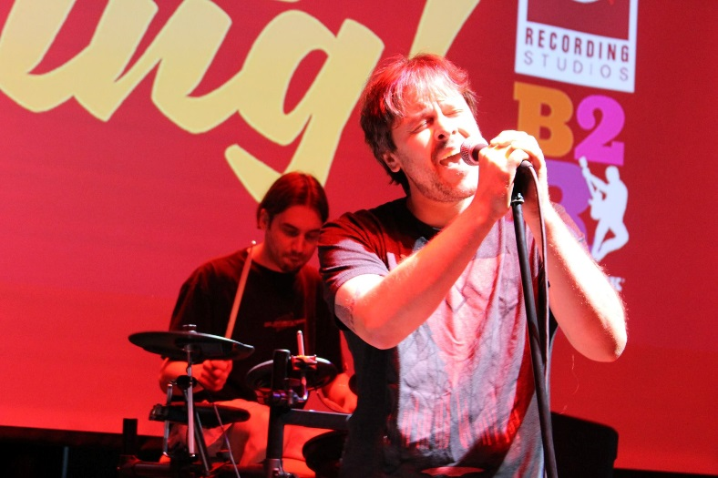

FOR IMMEDIATE RELEASE
August 14, 2017
Contact: Kelly Gilfether
Marketing Director/Manassas Mall
Telephone: 703.368.7232
E-mail: kellygilfether@pyramidmg.com

See Who Can Rock the Mic at The Stand Up & Sing Finals!
Manassas, VA. – Watch the top-10 Stand Up and Sing! performers compete for their first record deal in the August 15th finale at Uptown Alley. Come ready to be impressed and cheer on outstanding up and coming local artists! The show starts at 6:00pm, don’t miss out!
The top performer will earn a $1,000 recording package with lead engineer Ken Schubert at Cue Recording Studios; producers of 10 gold and platinum records to date. The second place winner will receive $500 Bach 2 Rock rehearsal/performance space rental and $150 American Express gift card. Last but not least the third place winner walk away with $150 Uptown Alley family fun pack and $100 American Express gift card.

###
For updates or information on Manassas Mall and other events, please visit our website at www.ManassasMall.com, like us on Facebook at www.facebook.com/manassasmall, and follow us on Twitter at www.twitter.com/manassasmall and Instagram at www.Instagram.com/manassasmall .

