
FOR IMMEDIATE RELEASE 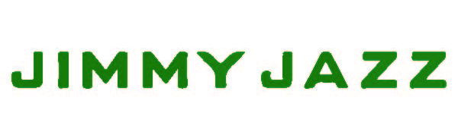
Contact: Kelly Gilfether
Marketing Director/Manassas Mall
Telephone: 703.368.7232
E-mail: kellygilfether@pyramidmg.com

JIMMY JAZZ is Now Open at the New Manassas Mall!
Grand Opening Celebration set for Saturday, April 29th

Manassas, VA – Manassas Mall is excited to announce that JIMMY JAZZ is now open and located next to The Children’s Place. The Manassas Mall store will mark the first location for JIMMY JAZZ in Northern Virginia. JIMMY JAZZ is a leading urban apparel and footwear retail chain with the latest trends in lifestyle, streetwear and footwear brands for men, women and children, including Nike, Jordan, Adidas, Polo Footwear, Levi's and Decibel.
JIMMY JAZZ strives to bring the latest in-demand brands to shoppers with easy and convenient shopping, by providing an ever-changing showcase of the newest fashion available for men, women, and kids. JIMMY JAZZ currently has 170 locations in the United States, the Manassas Mall location is their first store in Prince William County, and their fifth store in Virginia.
Join JIMMY JAZZ for their official Grand Opening Event on Saturday, April 29th beginning at 10am. Customers will receive a voucher card for 25% off clothing purchase for the entire day, along with a live DJ and giveaways.

###
For updates and information on events and new store openings please visit our website at www.ManassasMall.com. Like us on Facebook.com/ManassasMall and follow us on Twitter.com/ManassasMall and Instagram.com/ManassasMall.

