Join us on Nov. 18th
for Macy’s exclusive
Trunk Show by

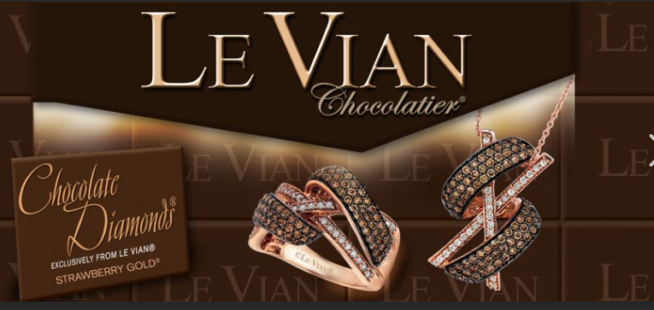

Book an appointment today with
a consultant and receive a
free gift the day of the show.

