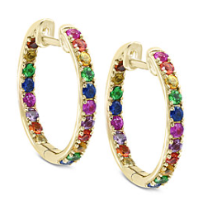
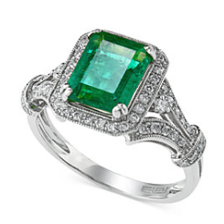
One Day Only
Designer Jewelry Event
Featuring
EFFY
February 27, 2019
10am-6pm
You are invited to a rare opportunity showcasing Effy Fine Jewelry. Effy is designed and hand-crafted in New York City using only the best quality gemstones, diamonds, and gold.

Only at

Macy’s Walden Galleria
716-684-6267
Extension 568
4 Walden Galleria Dr
Cheektowaga, NY 14225

Contact a Fine Jewelry consultant to book your appointment for this special one day only event!

Teal Box Specials:
