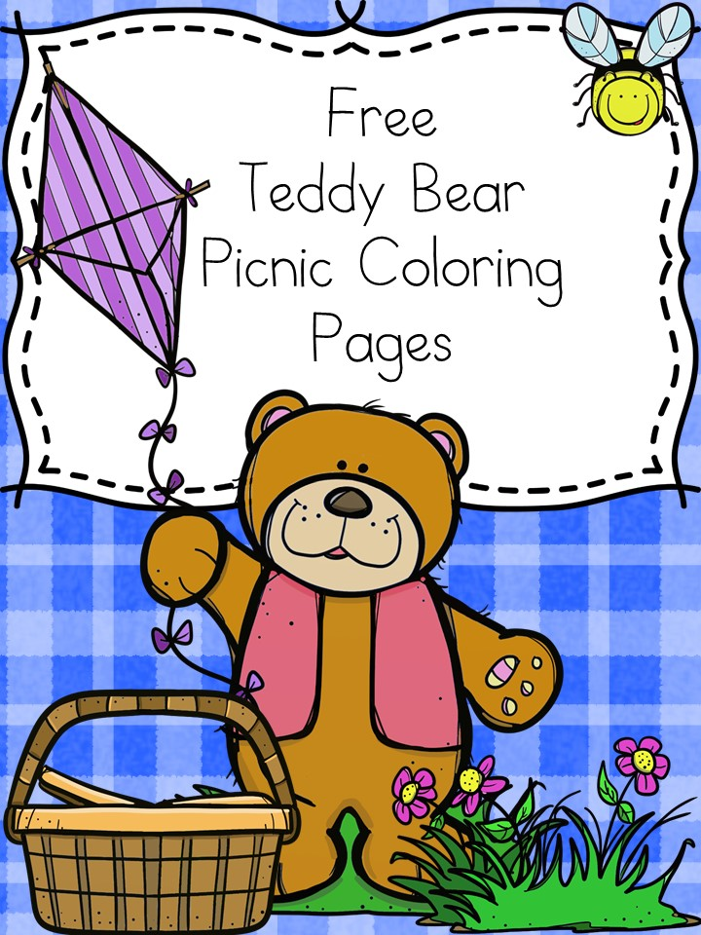

$22.99 per person
Includes Lunch, Power Card, activities & prizes!
Buy tickets now at:
https://dnb.ticketbud.com/dnb_buffalo_teddy_bear_picnic
*offer valid 7/10/17. Cannot be combined with any other offer. See store for details.

Send Invites Now
Check In Guests

Join us for a
Teddy Bear Picnic!
Dave and Buster’s
Walden Galleria
July 10th 11am-2pm

