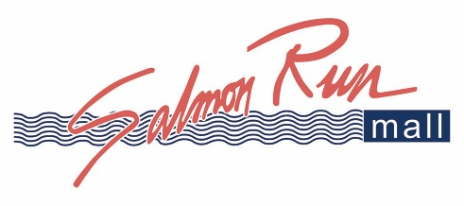

Media Release
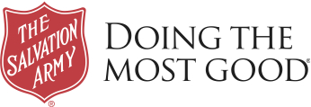
FOR IMMEDIATE RELEASE: November 18, 2020
Salvation Army Media Contact:
Stacey Davis
Director of Marketing and External Communications
Salvation Army Empire State Division
(315) 335-3953; Stacey.davis@use.salvationarmy.org

Salmon Run Mall Continues Longstanding Partnership with The Salvation Army Empire State Division Continues for 2020 Red Kettle Campaign
The Salvation Army Red Kettles Will be Set Up at Salmon Run Mall and Across Pyramid Shopping Destinations Throughout New York State

Watertown, New York (November 18, 2020) – Salmon Run Mall, owned by Pyramid Management Group, is proud to announce the continuation of the iconic “Red Kettle” holiday campaign and longstanding strategic partnership with the Salvation Army Empire State Division, joining 11 additional Pyramid shopping centers throughout New York State. The Salvation Army Empire State Division and Pyramid have been integral community partners in the communities they serve for 52 years, since the inception of Pyramid Management Group in 1968. Salmon Run Mall will begin its “Red Kettle” campaign on November 20th and will be located in Center Court, on the JC Penney side.

Last year, the “Red Kettle” partnership generated $3.8 million in donations from shopping center guests across Pyramid’s portfolio that directly benefitted those who need the support the most throughout the Empire State Division of the Salvation Army.

“The red kettles are an iconic part of The Salvation Army and we are grateful to have such a strong partnership with Pyramid Management Group to increase foot traffic around our kettles, especially during COVID times,” said Major Ivan Rock, Divisional Commander of the Empire State Division of The Salvation Army.

Needed funds that are typically raised through the organization’s iconic red kettles are at risk this year due to COVID-19 while requests for services are at an all-time high. To make the donation process safer this holiday season, all red kettles are equipped with NFC technology accepting Apple Pay and Google Pay. The Salvation Army has adopted nationally mandated safety protocols and implemented training around cleaning and sanitizing the red kettles. Digital donations through Apple Pay and Google Pay are also strongly encouraged to cut down on points of contact.

Pyramid Management Group is the largest privately held shopping center developer in the Northeast, owning, leasing, and operating 14 properties, 11 of which are in New York State and are part of the “Red Kettle” partnership.

The additional Pyramid properties and the exact dates of their red “Red Kettle” campaigns are as follows:

• Crossgates in Albany, NY – November through December 24
• Galleria at Crystal Run in Middletown, NY – November through December 24
• Palisades Center in West Nyack, NY – November 27-28, December 4-5, 11-12, 18-19, 21-24
• Poughkeepsie Galleria in Poughkeepsie – November through December 24
• Salmon Run in Watertown, NY – November 20 through December 24
• Sangertown Square in New Hartford, NY – November 26 through December 24
• Destiny USA in Syracuse, NY – November 6 through December 24
• Champlain Center in Plattsburgh, NY – November 3 through December 24
• Aviation Mall in Queensbury, NY – November 3 through December 24
• Walden Galleria in Buffalo, NY – November 9 through December 24

“Giving back to the communities we serve, particularly in times of greater need, is incredibly important to Pyramid Management Group and the guests who graciously choose to donate every holiday season at our properties,” said Stephen J. Congel, chief executive officer, Pyramid Management Group. “We are honored to continue this important tradition and partnership with the Salvation Army and provide our guests with an opportunity to give back in a manner that’s safe for everyone. The partnership is especially meaningful to our guests since the funds raised at each one of our centers remains in the communities they were donated.”

Based on the increase in services already provided in response to the COVID-19 pandemic, The Salvation Army could serve up to 155 percent more people nationwide in 2020 with Christmas assistance, including putting food on the table, paying bills, providing shelter and helping place gifts under the tree – assuming the resources are available. Throughout the Empire State Division last year, 4.3 Million meals were served. Since COVID-19 hit, 3 Million meals were served in just 6 months. If we see the same level of increased requests for service, that would mean 40% increase of people who need our help this holiday season.

The Salvation Army has adopted nationally mandated safety protocols and implemented training around cleaning and sanitizing the red kettles. Digital donations through Apple Pay and Google Pay are also strongly encouraged to cut down on points of contact.

Every donation provides help and hope to those in need, and all gifts stay within the community in which they are given. Visit empire.salvationarmy.org to donate or learn more about how you can help The Salvation Army rescue Christmas this year.

For more information on the upcoming holiday season or Salmon Run Mall’s comprehensive safety and sanitizing measures that have been implemented to help protect shoppers, tenants and employees at Salmon Run Mall, CLICK HERE.

