Holyoke Mall Sensory Voyage

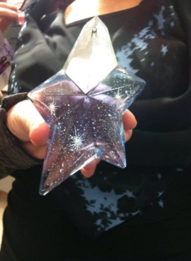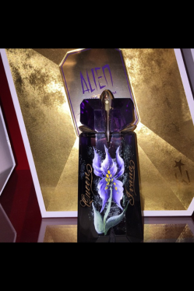

Angel and Alien customers! Join us at Macy’s Holyoke for some Mugler fun on Saturday July 15th starting at 12:00 -3:00 and 5:00-9:00. There will be complimentary Thierry Mugler samples, Thierry Mugler gifts, and delicious treats. Can’t make the event. Come to the fragrance counter and presell prior to the event date, and receive all of the perks without being there. Save the date. Don’t miss this special event. Reserve your seat. Seats are limited. Call fragrance counter 413-538-7360 ext. 2110.
